FIELD REPORT
Introduction
Place: Okole HC III
Location: Kole, Kole district
Date of visit: 25th August 2026
- General observations
- All UGIFT assets delivered to Okole Health Center III were physically identified and verified during the monitoring exercise. The In-Charge and facility staff provided full cooperation and support throughout the verification process.
- Storage space is inadequate, with the small store becoming congested and some equipment being kept along corridors due to lack of sufficient space.
- Some laboratory and medical equipment is not being fully utilized because staff have not received adequate training on its operation and maintenance.
- The facility requires repainting, as sections of the walls are peeling and visibly dirty, affecting the general appearance and cleanliness of the building.
Special notes
- All assets are not engraved
- The facility is making efforts to properly manage and utilize the UGIFT assets despite limitations in storage capacity and staff capacity.
- The storage constraints expose some equipment to unnecessary movement and potential damage, particularly where assets have to be kept outside the designated store.
- The skills gap may limit the effective utilization and proper maintenance of some of the newly provided equipment.

The table below illustrates some physical status of the verified assets with photographic evidence.
Table XXX: Physical verification photos
OKOLE HC III SIGN POST | 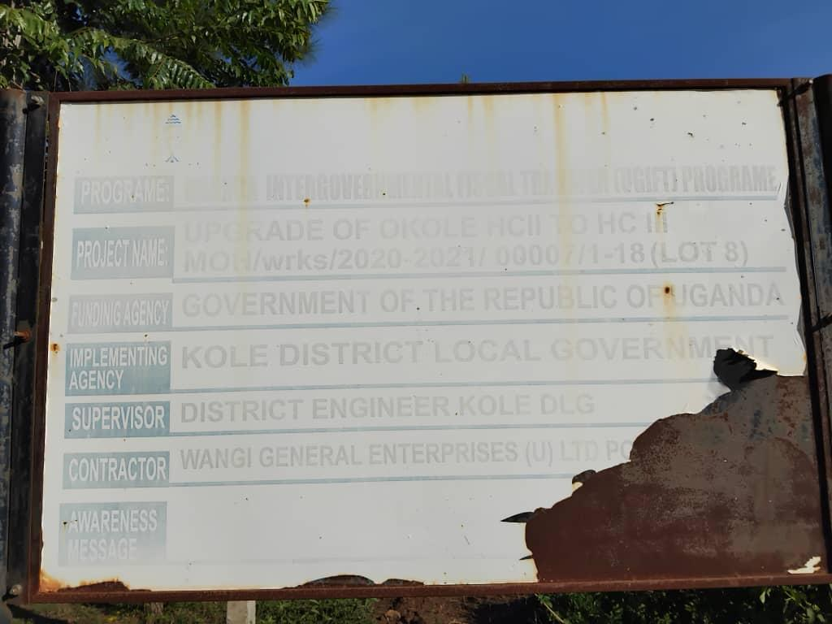
TYPICAL SET OF STAFF QUARTER’S BLOCK  (HOUSE BLOCK WITH TWO UNITS, KITCHEN) | 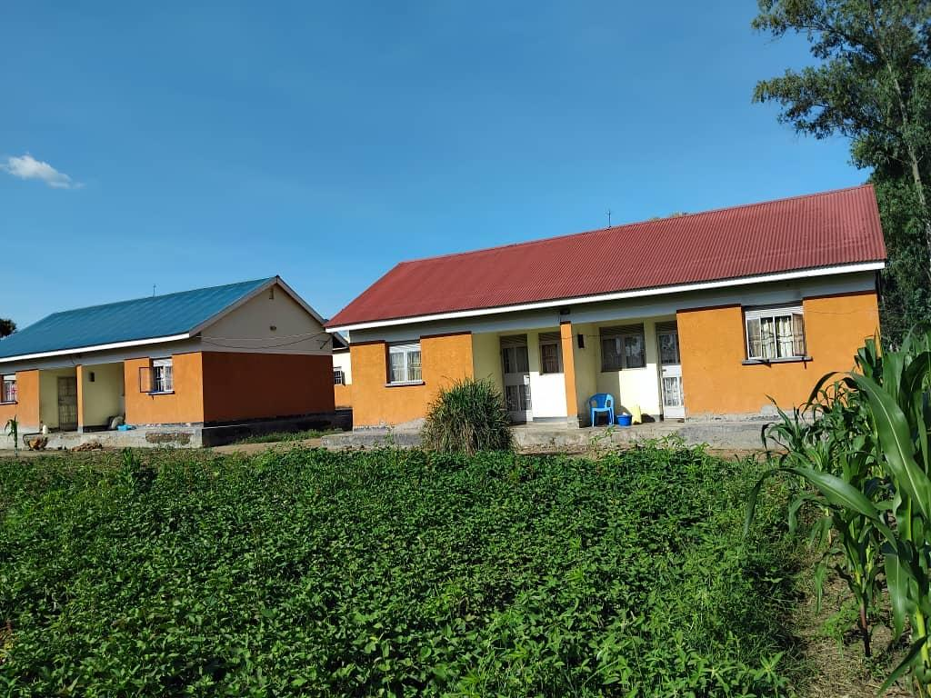
TYPICAL SET OF STAFF QUARTER’S BLOCK  (HOUSE BLOCK WITH TWO UNITS, KITCHEN BACK VIEW) | 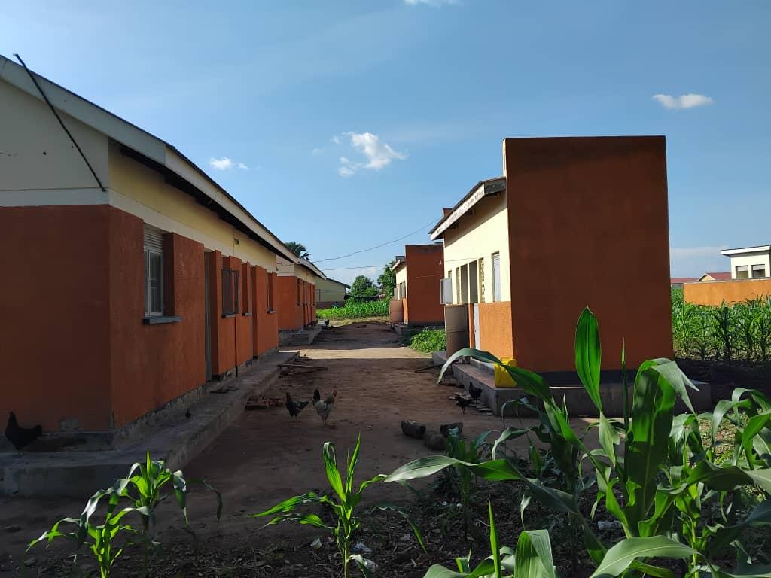
MATERNITY WARD/BLOCK (FRONT VIEW) | 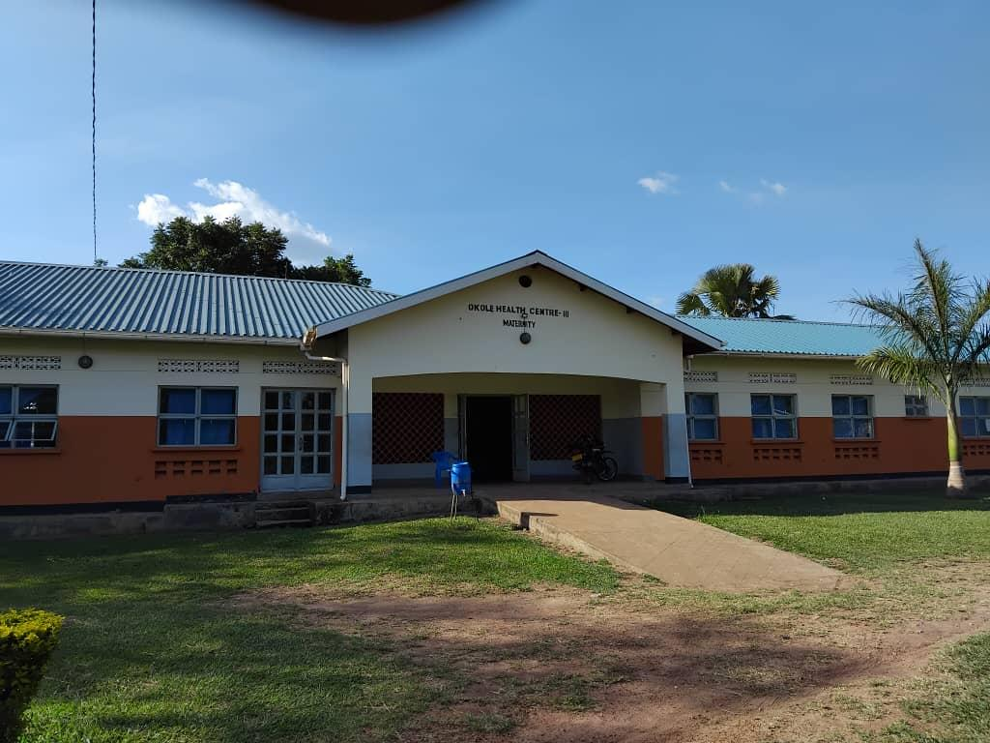
MATERNITY WARD/BLOCK (BACK VIEW) INCLUDING WATER TANKS SUPPLYING THE WARD/BLOCK | 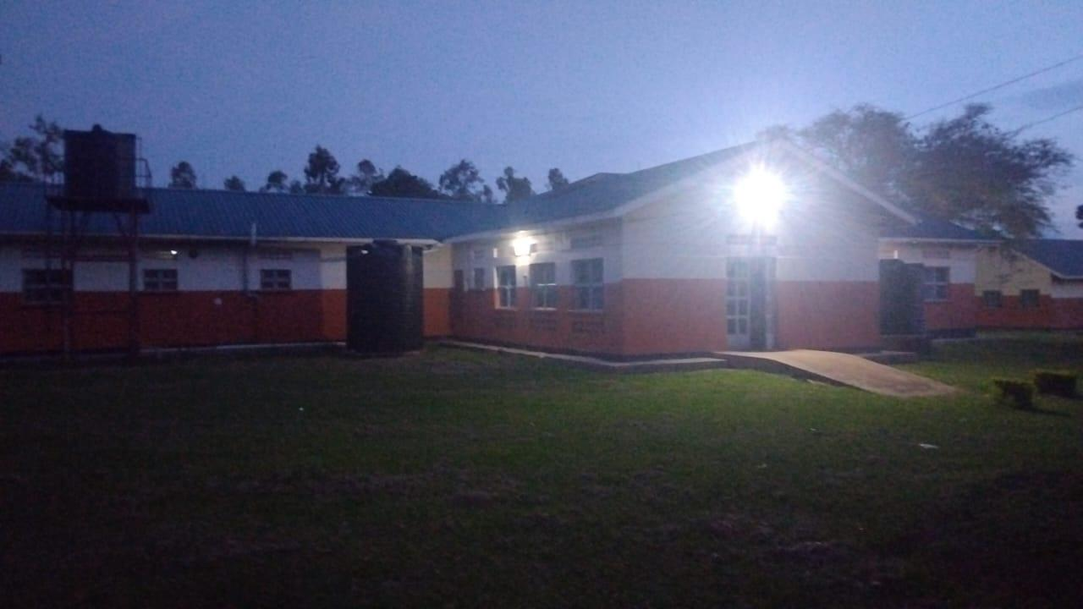
MATERNITY WARD/BLOCK (SIDE VIEW) | 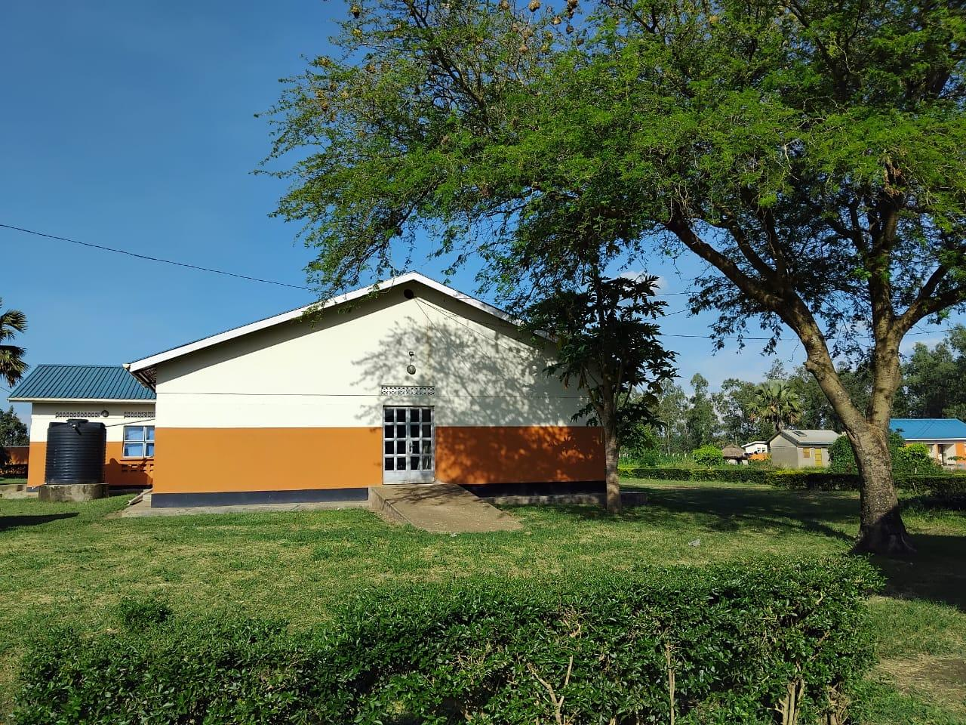
PLACENTA PIT | 